Part I.

1.

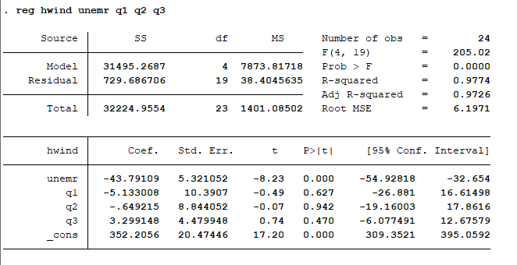

2. Jointly test hypothesis

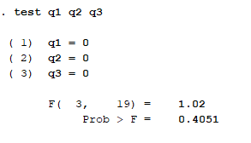

3. The seasonal dummy variables have different signs for different seasons which shows seasonal effect in the help-wanted index. If a student estimated above model without seasonal dummy variables, the effect of seasons in the help-wanted index is not captured by the model, which makes model less predictive compared to one with seasonal dummy variables.

|  |
| --- |
| SAS Code:  PART I:  Import Data:  **PROC** **IMPORT** OUT= WORK.bm  DATAFILE= "C:\Users\bmishra\Dropbox\Ph.D. Courseworks\Semest  er II, Spring 2019\Econometric Methods\Homeworks\Homework 3\HW3-DATA2.xl  s"  DBMS=EXCEL REPLACE;  RANGE="'FOOD COST$'";  GETNAMES=YES;  MIXED=NO;  SCANTEXT=YES;  USEDATE=YES;  SCANTIME=YES;  **RUN**;  Run the Model:  **proc** **reg** data = bijesh;  model hwind = unemr q1 q2 q3;  **run**;  test q1 = **0**; q2 = **0**; q3 = **0**;  **run**;  Data Manipulation:  **data** bm; set bm;  y = y;  x = x;  sqx = x\*\***2**;  cubx = X\*\***3**;  **run**;  Part II: Q1.  **Run the model:**  **proc** **reg** data = bm;  model y = x sqx cubx;  **run**;  **proc** **print**;  **run**;  **proc** **qlim** data = bm;  model y = x sqx cubx;  output out = outme, marginal;  **run**;  **proc** **print**;  **run**;  proc autoreg data = bm;  model y = x sqx cubx/ chow =(16);  run;  Test for Restriction:  Data = bm; set bm;  If obs ge 16 then s1 = 1; else s1 = 0; (ge -> greater or equal to.)  Run;  X >= 1 and x<= 3 (x in between 1 and 3)  If obs between 6 and 12 then s1 = 1; else = 0; (observations between 1 and 3 included)  Run;  Part II: Q4:  **Run the model:**  **proc** **reg** data = bm;  model y = x sqx cubx;  **run**; |
| **Import Data:**  **PROC** **IMPORT** OUT= WORK.bm  DATAFILE= "C:\Users\bmishra\Dropbox\Ph.D. Courseworks\Semest  er II, Spring 2019\Econometric Methods\Homeworks\Homework 3\HW3-DATA2.xl  s"  DBMS=EXCEL REPLACE;  RANGE="'FOOD COST$'";  GETNAMES=YES;  MIXED=NO;  SCANTEXT=YES;  USEDATE=YES;  SCANTIME=YES;  **RUN**;  **Also can be done manually using import data and open program.**  **Data management and defining variables:**  **data** bm; set bm;  y = y;  x = x;  sqx = x\*\***2**;  cubx = X\*\***3**;  **run**;  **Use of reg function:**  **proc** **reg** data = bm;  model y = x sqx cubx;  **run**;  **Use of means function:**  **proc** **means** data = bm;  x mean min max range std;  **run**;  **Print Result:**  **proc** **print**;  **run**;  Ramsey RESET test in Stata: ovtest  **data** bm; set bm;  y = y;  x = x;  sqx = x\*\***2**;  cubx = X\*\***3**;  **run**;  **proc** **print**;  **run**;  **proc** **reg** data = bm;  model y = x sqx cubx/ lackfit;  **run**;  **proc** **qlim** data = bm;  model y = x sqx cubx;  output out = abc, marginal;  **run**;  **proc** **reg** data = bm;  model y = x;  plot rstudent.*p/noline;  plot y*x;  **run**;  **quit**;  **proc** **loess** data = bm;  model y = x / smooth = **0.1**, **0.2**, **0.3**, **0.4**;  ods output outputstatistics = results;  **run**; |